**EASINGWOLD & VILLAGES COMMUNITY PARTNERSHIP – DRAFT WORKING PLAN**

October 2024 (Draft Version 6.0)

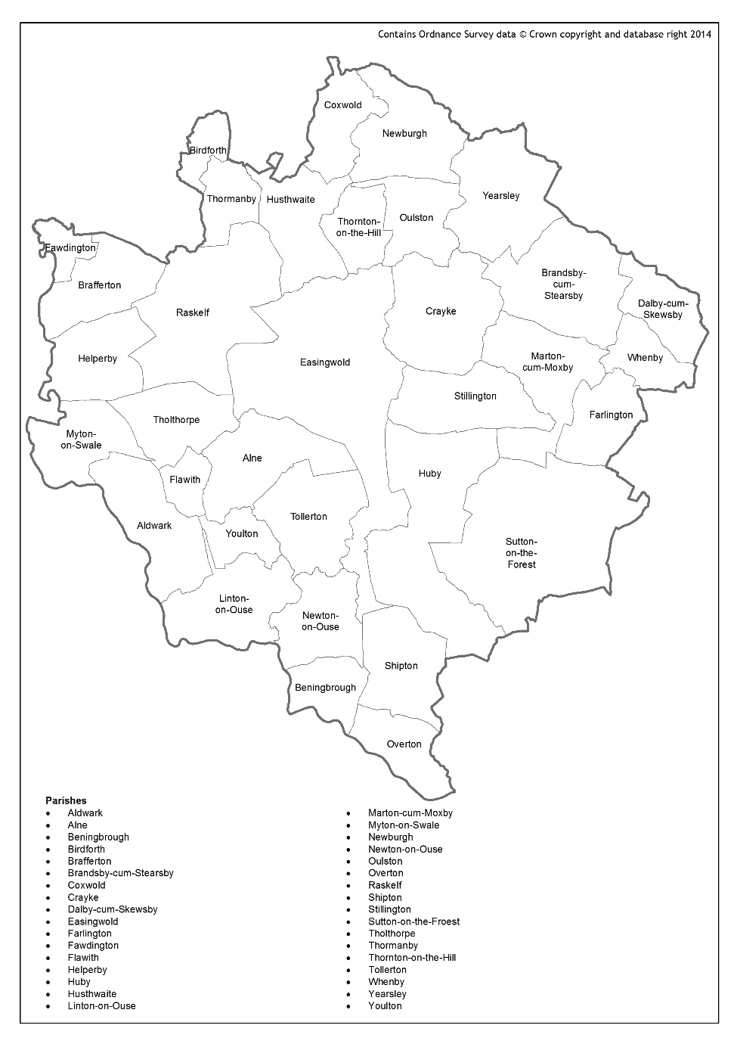

Proposed Easingwold & Villages Community Partnership Area – based on the former Easingwold & Villages Community Forum boundary and the Let’s Talk Local consultation.

**What do we know about the Easingwold & Villages Community Partnership Area?[1]**

|  |  |
| --- | --- |
| **Population** | * There are 16,128 people living in the Easingwold Community Partnership area. * 26.7% of the population are aged 65+ which is higher than the North Yorkshire and England average of 25% and 18.4% respectively. |
| **Vulnerable Groups** | * 11% of children aged 0-19 are in relative low-income families compared with 19% across England. * 58.2% of all pensioner households are lone pensioner households. Noting that pensioner households account for 34.4% of the total households across the area - which is significantly higher than the England average. * Benefit claim levels are below England average, with the exception of Attendance Allowance, PIP with respiratory disease, Universal Credit with Limited Capability for Work, and Disability Living Allowance which are closer to the England average. * Deprivation: on the measures of living environment, and barriers to housing and services domains, Easingwold Community Partnership area is significantly higher than the national average. |
| **Housing** | * Above England average of owner occupation (69%) and Registered Social Landlord Rented (12%). * The housing affordability gap is significantly above national average. * 1.4% of households lack central heating compared with 1.5% across England. |
| **Crime & Safety** | * The overall crime rate is significantly lower than the average across England. |
| **Health & Wellbeing** | * 14.5% of people have a limiting long-term illness where day to day activities are limited compared with 17% across England. * Those with musculoskeletal conditions are in line or slightly above the national average. * Although healthy eating levels are above the regional and England averages, binge drinking is also reported as being higher than the regional and England average. |
| **Education & Skills** | * 13% of people have no qualifications compared with 18% across England. * Above national average for those who have a qualification level 4 (degree). * Above national average in pupil attainment in all keys stages. |
| **Economy** | * 28% people aged 16-74 are in full-time employment compared with 34% across England. * 43% of the population (16-74) are economically inactive, compared to the England average of 39%. * In line with national average for household income. * 18% of households living in fuel poverty, which is higher than the England average of 13%. * Small and Medium Enterprise lending debt is five times the England average at £11,041 per head. * The largest business sector is agriculture, followed by construction and professional, scientific and technical services. |
| **Access & Transport** | * 6% of households have no car compared with 24% across England. * Above national averages for travel distance required for key services. * Average broadband download speed is below the England average. * In the 2020 Census, Easingwold & Villages Community Partnership area residents were much less likely to engage with digital response routes, with higher than North Yorkshire and England averages for paper responses. |
| **Communities & Environment** | * The % of people 'satisfied with their neighbourhood' (91%) is higher than the average across England (79.3%) * The number of ‘rural’ residents is nine times the England average, with those classed as ‘hard pressed living’ at 5.7%. * Almost six times the England average of ‘e-rational utilitarians’ in terms of internet usage classification. This comprises mainly rural/semi-rural areas with higher than average retired populations, constrained by poor infrastructure. Users undertake online shopping, and the Internet is used as a utility rather than a conduit for entertainment. * Lower than England average voter turnout at local elections. * Double the England average on the active and engaged community score. This measures the levels of third sector civic and community activity and barriers to participation and engagement. It shows whether charities are active in the area, and whether people appear to be engaged in the broader civic life of their community. * Total grants awarded from major funders is below the England average (this encompasses major foundations and trusts). |

**What are the priorities for those in the Easingwold & Villages area?**

**Let’s Talk Local (2022/23)**

The findings of the Let’s Talk Local Campaign, delivered by North Yorkshire Council in winter 2022/2023, highlighted the following resident priorities:

Draft Community Partnership Boundary

* General consensus from all respondents that the proposed boundary for the Easingwold Community Partnership made sense, with people highlighting the importance of involving the surrounding villages.

Access & Connectivity

* Providing the infrastructure for more active travel – creation and development of more off-road footpaths for pedestrians and cyclists to navigate around the rapidly expanding town of Easingwold. This can be achieved by adopting existing estate roads and public areas from the developers and building off-road paths to enable safe and sustainable non-motorised and foot traffic between estates, shops and schools.
* Lack of bus services, both to and from Easingwold, and connecting the villages to key services. This is a particular problem in the evenings and weekends.

Infrastructure & Public Realm

* Lack of access to a petrol station nearby.
* Lack of variety in supermarkets, accessing food in Easingwold is expensive.
* Road surfaces are poorly maintained, and not tended to in winter months when conditions are at their worst.
* Require speed restricted areas around all schools, and in site specific areas.
* Concern about the lack of services given the growth that is anticipated, worried that Easingwold will become a commuter town.

Health & Wellbeing

* Retired loneliness is frequent, need more social activities for the older population.

**Easingwold & Villages Community Plan (2016-2020)**

The Easingwold & Villages Community Plan overseen by the Easingwold & Villages Community Forum, consisted of the following priorities:

* Improving health and wellbeing
* Improving access to services
* Supporting economic growth
* Supporting a changing population

There was also a dedicated Easingwold Town Team Plan focussing on economic growth and development of Easingwold. The Easingwold Town Investment Plan (2022), commissioned by the former Hambleton District Council, outlines a detailed set of recommendations focussing on potential investment priorities and opportunities.

**Draft Easingwold & Villages Community Partnership Priorities**

|  |  |  |
| --- | --- | --- |
| **Health & Wellbeing** | | |
| **Priority** | **Action** | **Progress** |
| Access to health services in rural communities. | * Engage with local health care providers and Patient Participation Group to understand access challenges for those in the area, working collaboratively to identify potential solutions. |  |
| **Access to Services & Connectivity** | | |
| **Priority** | **Action** |  |
| Access to services and facilities for children and young people. | * Work with the local youth provision and the police to understand the on-going challenge of ASB identified in Easingwold and Stillington. | Contact with Outwood Academy Y12 students with Community Anchor meeting scheduled in November |
| * Explore funding opportunities to improve provision, and access to provision, for children and young people where a need has been identified |  |
| Access to services and activities for older people across the Community Partnership area. | * Increase awareness raising of services and activities available in the area in a variety of formats. | Let’s Get Connected and The Blue Book are widely available detailing activities for older people in Easingwold and the surrounding villages |
| Access to services for all, including banking and post office services. | * Work with service providers and government sponsors to encourage the provision of local accessible services |  |
| Development of, and support for, the voluntary sector offer in the area. | * Work with the local Community Anchor Organisation (CAO)[2] to improve levels of communication with and between local community and voluntary groups across the CP area. | Meetings held in June and October with invitations sent to all local community groups in the area |
| Access to fibre, high speed broadband and mobile phone coverage in rural communities. | * In conjunction with the NYC Mobile Access Project Manager, explore and map ‘not spots’ in the area, and identify potential solutions. | Work with NYC ongoing |
| **Infrastructure & Public Realm** | | |
| **Priority** | **Action** |  |
| Improved and sustainable local community assets including village halls and community buildings. | * Work with Town/Parish Councils to map existing community assets, identify any ‘at risk’ and provide support to those seeking funding to improve the state of repair of village halls and community buildings. |  |
| Improved local transport provision, particularly focussing on evenings and weekends. | * Work with the voluntary sector, NYC, the new Mayoral Team and transport providers to identify gaps in provision and to explore opportunities for collaborative and sustainable solutions. | A Sunday bus service has been funded for 12 months from December between Easingwold and York. Work is being undertaken to arrange a service between outlying villages and Easingwold on Market Day |
| Improved condition and safety of the road network. | * Work with outlying villages to explore reviewing and re-developing the Community Speedwatch scheme. | Presentation by NYP with regards to Community Speedwatch |
| Inclusive and sustainable active travel infrastructure across the Community Partnership area, particularly focussing on walking and cycling. | * Support and encourage the collaboration of local Path keeper Groups, sharing knowledge and best practice. |  |
| * In conjunction with the Area Constituency Committee, support the feasibility being undertaken to develop the Easingwold to Crayke cycle/pathway. |  |
| * Liaise with Parish Councils to monitor areas that are prone to flooding, ensuring that gullies and drainage is clear. |
| * Encourage Parish Councils to take advantage of the NYC Parish Portal to report any issues. |
| **Local Growth** | | |
| **Priority** | **Action** |  |
| Safe and inclusive parking opportunities in Easingwold, including access to EV charging points. | * Work with NYC to identify and implement appropriate schemes and improve enforcement services. |  |
| The provision of affordable housing. | * Continue to monitor the identified need for affordable housing. |  |
| * CP to develop and maintain links with the NYC Rural Housing Enabler and local Registered Social Landlords (RSLs). |
| Improved and maintained local signage, particularly for amenities and car parks. | * Work with Town/Parish Councils to ‘audit’ signage and identify where signage improvements or replacements are required. |  |
| The maintenance of Easingwold as a vibrant market town and Service Centre for local villages and promotion of the area as a tourist destination of choice. | * Monitor vacancy rates in Easingwold and work in partnership with the Town Council and the Wold Class Business Network to ensure Easingwold remains a vibrant and sustainable market town, one that is attractive to new businesses. |  |
| * Support the work of the Easingwold Tourist Information Centre and the Wold Class Business Network to raise the profile of Easingwold’s tourism offer and ensure that Easingwold and the surrounding villages benefit from the NYC Destination Management Plan. |  |
| **Community Resilience** | | |
| **Priority** | **Action** |  |
| The Easingwold & Villages Community Emergencies & Resilience Plan. | * Support the development of the Easingwold & Villages Community Emergencies & Resilience Plan. | Presentation by Tim Townsend, Emergency Planning Manager  Resilience and Emergencies Team, NYC. Meetings arranged to develop localised plans for Easingwold and villages |

1. Oxford Consultants for Social Inclusion (OCSI), [www.ocsi.co.uk](http://www.ocsi.co.uk)
2. *North Yorkshire Council are currently developing the Community Anchor model across the County in conjunction with place based, locally rooted, community and voluntary sector partners, as part of a three-year developmental programme. The CAO for Easingwold & District Community Care Association (EDCCA) for Easingwold and the surrounding area.* 